**About the Dataset**

|  |  |  |  |
| --- | --- | --- | --- |
|  | **Database 1** | **Database 2** | **Database 3** |
| Intact Subjects | 27 | 40 | 0 |
| Trans-radial Amputated Subjects | 0 | 0 | 11 |
| sEMG Electrodes | 10 Otto Bock | 12 Delsys | 12 Delsys |
| Total Number of Movements (rest included) | 53 | 50 | 50 |
| Number of Movement Repetitions | 10 | 6 | 6 |
| ***Exercise 1*** | | | |
| Reference in [Fig. 2](https://www.nature.com/articles/sdata201453#Fig2) | Exercise A | Exercise B | Exercise B |
| Number of Movements | 12 | 17 | 17 |
| Ground Truth Parameter | Hand Kinematics | Hand Kinematics | Hand Kinematics *(when available)* |
| Hand Kinematics/Dynamics Sensors | Cyberglove II | Cyberglove II | Cyberglove II *(when available)* |
| ***Exercise 2*** | | | |
| Reference in [Fig. 2](https://www.nature.com/articles/sdata201453#Fig2) | Exercise B | Exercise C | Exercise C |
| Number of Movements | 17 | 23 | 23 |
| Ground Truth Parameter | Hand Kinematics | Hand Kinematics | Hand Kinematics *(when available)* |
| Hand Kinematics/Dynamics Sensors | Cyberglove II | Cyberglove II | Cyberglove II *(when available)* |
| ***Exercise 3*** | | | |
| Reference in [Fig. 2](https://www.nature.com/articles/sdata201453#Fig2) | Exercise C | Exercise D | Exercise D |
| Number of Movements | 23 | 9 | 9 |
| Ground Truth Parameter | Hand Kinematics | Hand Dynamics | Hand Dynamics *(when available)* |
| Hand Kinematics/Dynamics Sensors | Cyberglove II | FFLS | FFLS *(when available)* |

https://www.nature.com/articles/sdata201453/tables/2

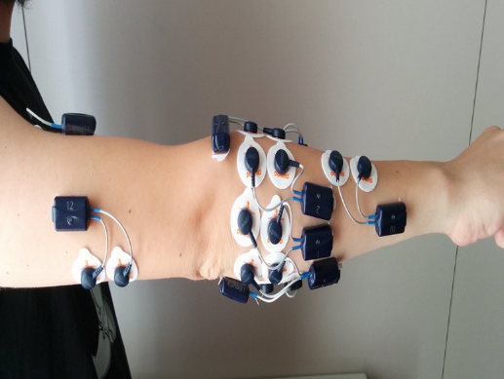

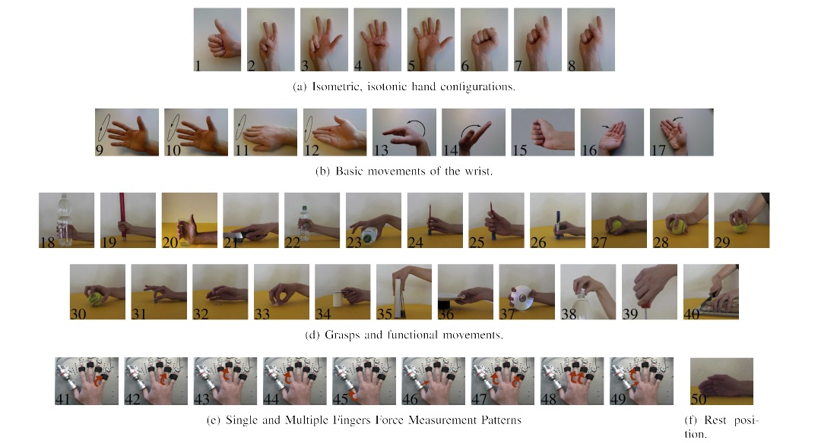

**Dataset Information**



|  |  |
| --- | --- |
| Machine Learning Models | Raw Data Model Prediction |
| Random Forest Classifier | 68.58 |
| KNeighborsClassifier | 67.82 |
| Support Vector Machine | 63.79 |
| Decision Tree | 62.96 |
| Logistic Regression | 60.29 |

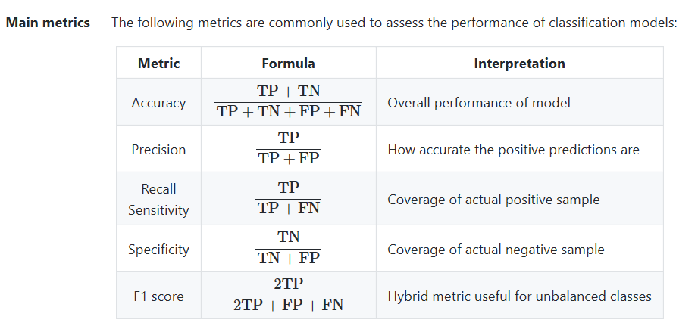

**Filtering Data**



|  |  |  |
| --- | --- | --- |
| Machine Learning Models | Raw Data Model Prediction | Filtered Data Model Prediction |
| Random Forest Classifier | 68.58 | 90.67 |
| KNeighborsClassifier | 67.82 | 88.97 |
| Support Vector Machine | 63.79 | 83.98 |
| Decision Tree | 62.96 | 85.36 |
| Logistic Regression | 60.29 | 79.07 |

**Feature selection with correlation**

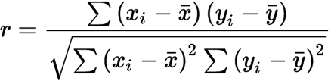

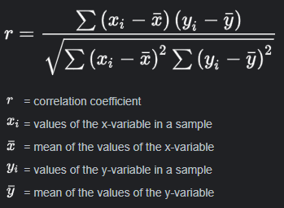

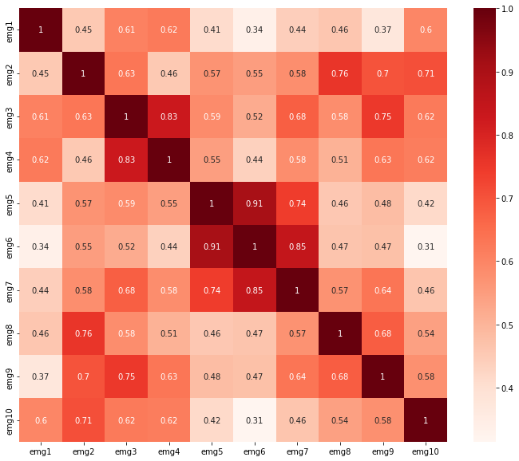

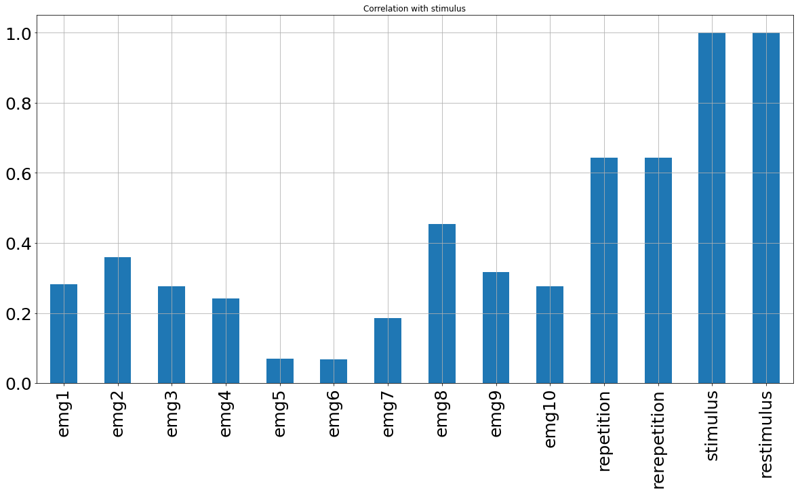

|  |  |  |  |
| --- | --- | --- | --- |
| Machine Learning Models | Raw Data Model Prediction | Filtered Data Model Prediction | After Dropping EMG 6 Column Model Prediction |
| Random Forest Classifier | 68.58 | 90.67 | 90.62 |
| KNeighborsClassifier | 67.82 | 88.97 | 88.96 |
| Support Vector Machine | 63.79 | 83.98 | 83.99 |
| Decision Tree | 62.96 | 85.36 | 85.35 |
| Logistic Regression | 60.29 | 79.07 | 79.09 |

**Feature Scaling**

**ML Models sensitive to feature scale**

**Algorithms that use gradient descent as an optimization technique**

* Logistic Regression
* Neural Networks

**Distance-based algorithms**

* Support Vector Machines
* KNN

**ML models not sensitive to feature scale**

**Tree-based algorithms**

* Decision Tree
* Random Forest

|  |  |  |  |  |
| --- | --- | --- | --- | --- |
|  | **Filtered Data Model Prediction** | **Min-Max Scaler** | **Standard Scaler** | **Robust Scaler** |
| **Random Forest Classifier** | **90.67** | 90.65 | 90.84 | 90.68 |
| **KNeighborsClassifier** | **88.97** | 88.56 | 88.77 | 88.31 |
| **Support Vector Machine** | **83.98** | 84.54 | 84.51 | 83.62 |
| **Decision Tree** | **85.36** | 85.38 | 85.52 | 85.42 |
| **Logistic Regression** | **79.07** | 76.72 | 81.37 | 80.39 |

**Statistical Analysis**

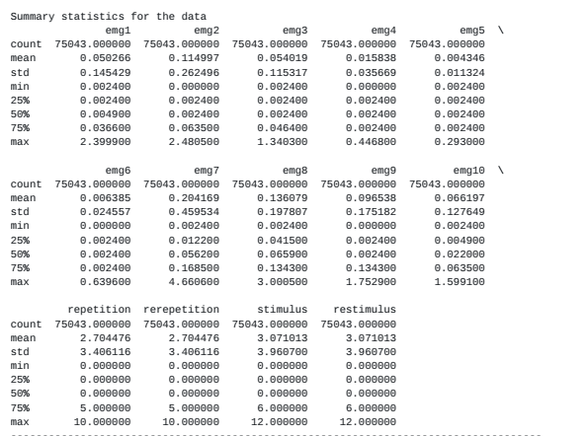

**Standardization (Z-Square):**

Scales features such that the distribution is centered around 0, with a standard deviation of 1.

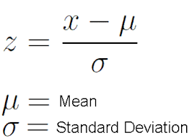

**Normalization (Min-Max Scaler):**

Shrinks the range such that the range is now between 0 and 1 (or -1 to 1 if there are negative values)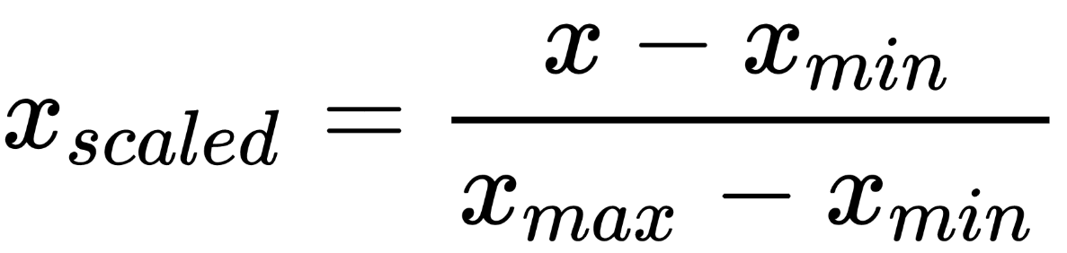

**Robust Scaler (Median-quantile Normalization)**:

Similar to normalization but it instead uses the interquartile range, so that it is robust to outliers.

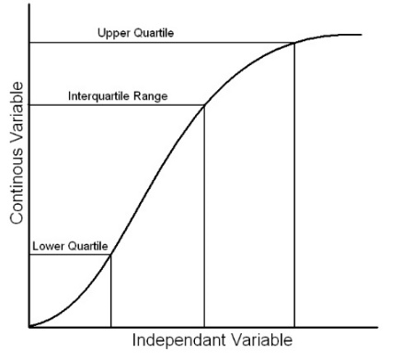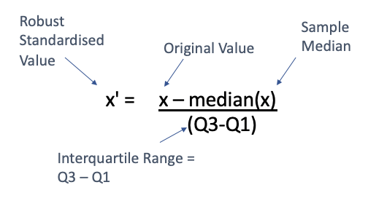

**Final Result**

|  |  |  |  |  |
| --- | --- | --- | --- | --- |
| Machine Learning Models | Raw Data Model Prediction | Filtered Data Model Prediction | After Dropping EMG 6 Column Model Prediction | Standard Scaling Model Prediction |
| Random Forest Classifier | 68.58 | 90.67 | 90.62 | 90.59 |
| KNeighborsClassifier | 67.82 | 88.97 | 88.96 | 88.79 |
| Support Vector Machine | 63.79 | 83.98 | 83.99 | **84.59** |
| Decision Tree | 62.96 | 85.36 | 85.35 | 85.38 |
| Logistic Regression | 60.29 | 79.07 | 79.09 | **81.24** |

**Random Forrest Classification Results**



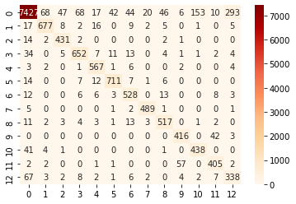

**Scopes of Improvement**



